Practical 2 B

import java.util.\*;

class sinx

{

public static void main(String args[])

{

Scanner sc= new Scanner(System.in);

System.out.print("Number of terms: ");

int n=sc.nextInt();

System.out.print("Find the sine of(please remember to put input in radians): ");

double x =sc.nextDouble();

System.out.println();

double sin=0.0;

int sign=1;

int ctr=0,i=0;

while(ctr<=n)

{

if(i%2 !=0)

{

sin+=(double)(sign\*Math.pow(x,i)/fact(i));

sign\*=-1;

ctr++;

}

i++;

}

System.out.println("sin("+x+")= "+sin);

}

public static int fact(int a)

{

int p=1;

for(int i=1;i<=a;i++)

p\*=i;

return p;

}

}

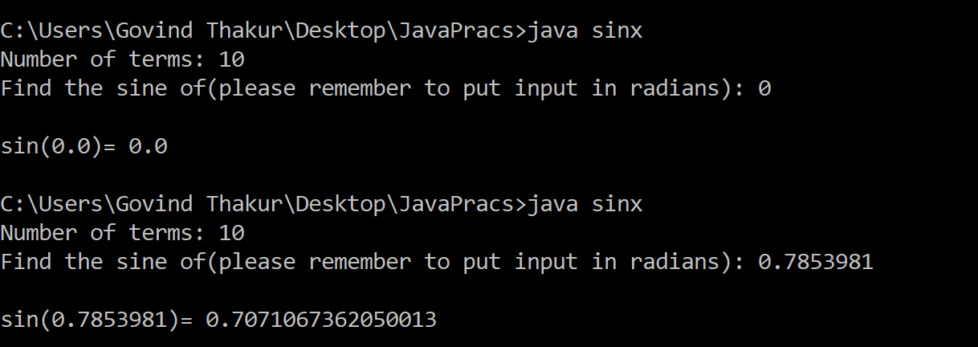OUTPUT:

